이근호님
Thanksgiving & Chuseok (강사용)
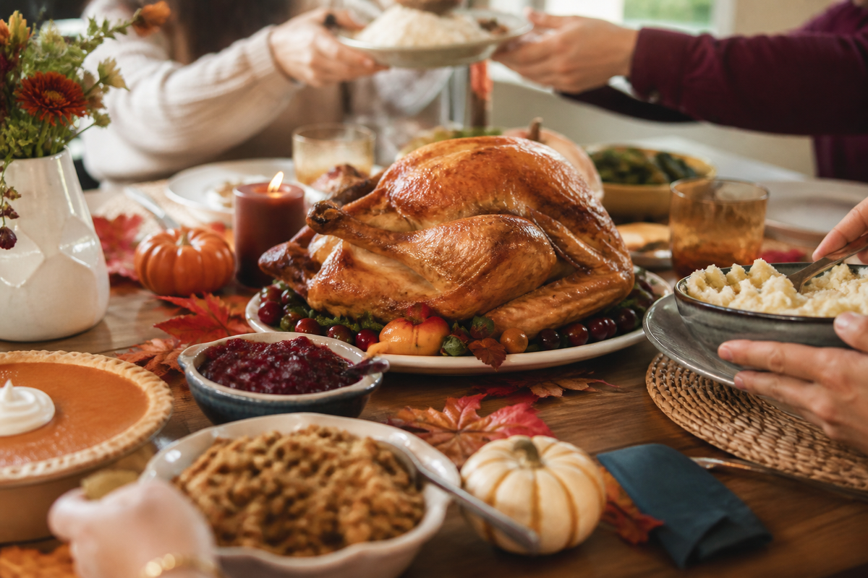
Warm-Up / Vocabulary / Reading / Comprehension / Idioms / Discussion

Warm-Up
Q What do you know about the history of Thanksgiving? Why do people celebrate it?
Q When is harvest season in Korea, and what foods are in season then?
Q What do Chuseok and Thanksgiving have in common?
Q What are you thankful for right now?

Vocabulary Preview
Match the words with their meanings.
e 1. harvest (수확) | a) a person who starts to live in a new place
h 2. lunar (음력의, 달의) | b) shaped like a half-moon
f 3. honor (기리다, 존경을 표하다) | c) hunger, not enough food
k 4. ancestor (조상) | d) a large meal for a celebration
a 5. settler (정착민) | e) food gathered from the land, such as grains and vegetables
i 6. colony (식민지, 개척지) | f) to show respect for
c 7. starvation (굶주림) | g) thankful
d 8. feast (잔치, 축제 음식) | h) of the moon
b 9. crescent (초승달 모양) | i) a new region settled by people from another country
l 10. customary (관례적인) | j) to make more beautiful
j 11. decorate (장식하다) | k) a family member from long ago
g 12. grateful (감사하는) | l) traditional, done as a custom
Reading 1 — Thanksgiving
1 Harvest festivals have been held throughout the world for thousands of years. The ancient Greeks held a three-day festival every autumn to honor Demeter, their goddess of grain, and the Romans held a fall festival for Ceres with music, games, parades, and a feast. The ancient Chinese celebrated a harvest festival on the fifteenth day of the eighth month of the lunar calendar — the same day as Chuseok — by baking round, yellow “moon” cakes.

2 The American Thanksgiving we know today began almost 400 years ago. In 1620, a group of about 100 people called the Pilgrims left England looking for religious freedom and a better life in America. When they arrived, their first winter was very difficult, and many of them died from starvation and disease.

3 The following year, Native Americans taught the settlers how to grow corn in the unfamiliar soil, how to collect sap from maple trees to make syrup, how to gather wild rice, and how to fish and hunt. In 1621, the Pilgrims had a very successful harvest and were able to put away food for the long winter ahead. They had a lot to be thankful for, so they planned a large feast and celebrated for three days, inviting the Native Americans who had taught them so much. In 1863, President Abraham Lincoln declared Thanksgiving a national holiday, and today Americans celebrate it on the fourth Thursday in November. Canadians celebrate earlier, on the second Monday in October, because their harvest comes earlier.

4 In both countries, Thanksgiving is a day to stop working and give thanks for one's life, health, family, food, and freedom. Most families share a festive meal with traditional dishes such as turkey and stuffing, mashed potatoes, cranberry sauce, and, of course, pumpkin pie for dessert.

Reading 2 — Chuseok
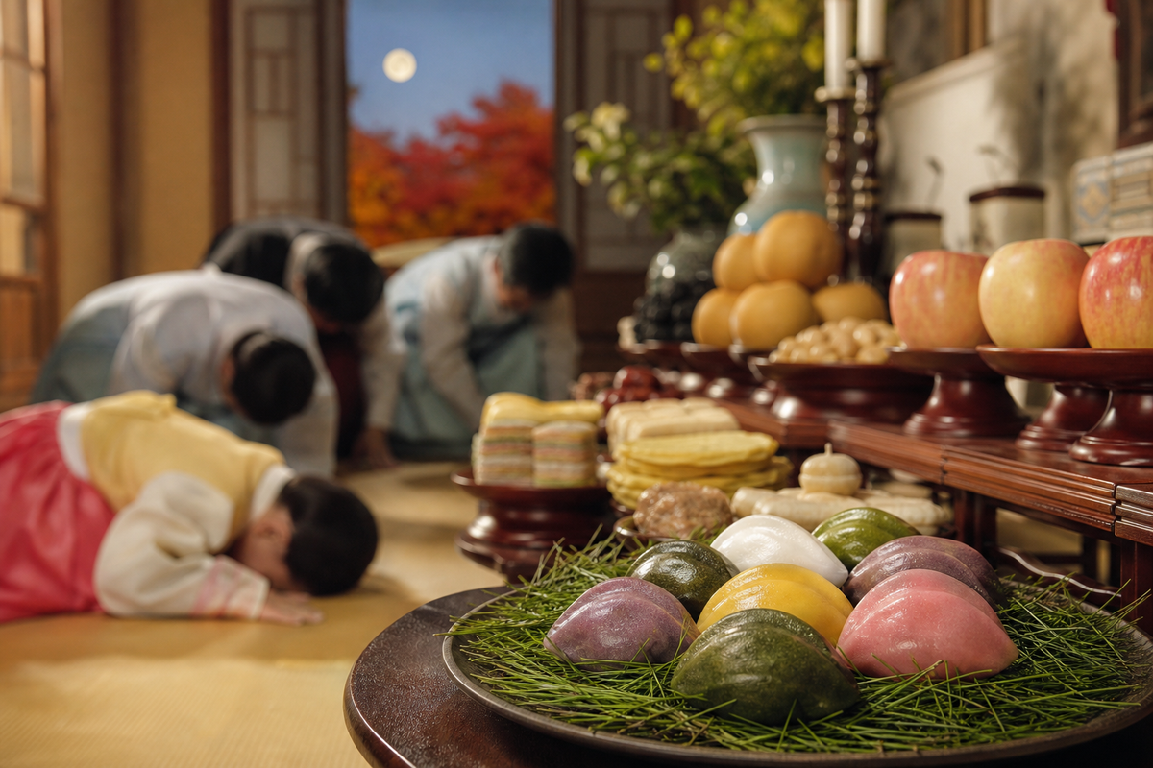
1 Chuseok is a Korean festival of harvest. It takes place each autumn on the 15th day of the eighth month of the lunar calendar, during the full moon. Chuseok is actually a three-day festival with celebrations before and after Chuseok Day. Many Asian countries celebrate a similar mid-autumn moon festival under other names.

2 Like American and Canadian Thanksgiving, Chuseok centers around family get-togethers and feasts. The traditional food served on Chuseok Day is songpyeon, half-moon rice cakes. These carefully crafted rice cakes are filled with sesame seeds, beans, or chestnuts and then shaped into crescents. They are placed on a bed of pine needles before being steamed. Well-prepared songpyeon symbolizes good luck.

3 Showing respect to ancestors is also central to Chuseok. Many Korean families use this holiday to visit and clean up their ancestors' graves, and they bring food offerings.

4 Traditional Korean games such as ssireum (Korean wrestling), tug-of-war, and neolttwigi (seesaw jumping) are customary during Chuseok. People also enjoy dancing and singing together under the harvest moon.

Comprehension
Q Why did the Pilgrims leave England?

Q What happened to the Pilgrims during their first winter in America?

Q How did the settlers learn to survive in their new land?

Q Why is Canadian Thanksgiving earlier than American Thanksgiving?

Q When does Chuseok take place?

Q How are songpyeon made?

Q What do many Korean families do to show respect to their ancestors during Chuseok?

Compare & Contrast
Fill in the table using the readings and your own knowledge.
 | Thanksgiving | Chuseok
When | 4th Thursday in November (US) / 2nd Monday in October (Canada) | 15th day of the 8th lunar month; a three-day holiday
Traditional food | turkey and stuffing, mashed potatoes, cranberry sauce, pumpkin pie | songpyeon, jeon, fresh fruit, a big family feast
Main activities | a family dinner, giving thanks, parades and football on TV | visiting ancestors' graves, charye, ssireum and other games, singing under the moon
Origin / meaning | giving thanks for the harvest; began with the Pilgrims' feast in 1621 | giving thanks for the harvest and honoring ancestors under the full moon
Idioms & Expressions
Expression | Meaning
grateful / thankful / appreciative | thankful (감사하는)
show one's gratitude | to show how grateful you are (감사를 표하다)
thank goodness / thank heavens | an expression used to express relief (다행이다)
thanks a million | thank you very much (정말 고마워)
thank one's lucky stars | to feel grateful because you were very lucky (운이 좋았음에 감사하다)
count one's blessings | to be very thankful for all that you have (가진 것에 감사하다)
feel stuffed / be stuffed | to feel very full from eating a lot (배가 터질 것 같다)
go cold turkey / quit ~ cold turkey | to quit a habit all at once, not gradually (단번에 끊다)
talk turkey | to discuss a deal very seriously (본론을 이야기하다, 진지하게 협상하다)

Choose one of the expressions above to complete each sentence.
1 If the owner of the business really wants to sell, he will ____________________.
2 I am very ____________________ to you for all your help.
3 Last night he threw a full package of cigarettes in the garbage. He decided to ____________________.
4 You can ____________________ that a doctor was close by when you had your heart attack.
5 Thanksgiving is a day for all of us to ____________________.
6 ____________________ for everything you have done for me!
7 ____________________ you arrived safely! We were very worried about you.
8 I can't eat another thing! I feel ____________________.

Discussion
Q Which festival would you rather take part in, Thanksgiving or Chuseok? Why?

Q Now that you're married, how has Chuseok changed for you? Do you visit both families?

Q Many Koreans say Chuseok is more stressful than relaxing. Do you agree?

Q If you hosted a Thanksgiving dinner in Korea, what would you serve?

Answer Key — 모범답안
Warm-Up
Q What do you know about the history of Thanksgiving? Why do people celebrate it?
A As far as I know, it started with the Pilgrims. They came to America from England about 400 years ago, and after a terrible first winter, Native Americans taught them how to farm. When they finally had a good harvest, they held a big feast to give thanks. That's where the holiday comes from.
제가 알기로는 필그림들에게서 시작됐어요. 400년쯤 전에 영국에서 미국으로 왔는데, 끔찍한 첫 겨울을 보낸 뒤 원주민들이 농사를 가르쳐 줬죠. 마침내 수확이 잘되자 감사의 잔치를 열었고, 그게 이 명절의 시작이에요.

Q When is harvest season in Korea, and what foods are in season then?
A In Korea, harvest season is September and October. That's when the new rice comes in, and fruits like pears, apples, persimmons, and chestnuts are in season. That's also why Chuseok falls in that period.
한국의 수확철은 9~10월이에요. 햅쌀이 나오고 배, 사과, 감, 밤 같은 과일이 제철이죠. 추석이 그 시기에 있는 것도 그래서예요.

Q What do Chuseok and Thanksgiving have in common?
A Both are harvest festivals, so they're about giving thanks for the year's crops. Both center around a big family meal, and both involve a lot of traveling to get home. The main difference is that Chuseok also focuses on honoring ancestors.
둘 다 수확 축제라서 한 해 농사에 감사하는 날이에요. 둘 다 가족 식사가 중심이고, 고향 가는 길이 막히는 것도 비슷하죠. 가장 큰 차이는 추석은 조상을 기리는 의미도 있다는 거예요.

Q What are you thankful for right now?
A Right now, I'm thankful that my wife and I are both healthy and that our company is growing. Honestly, I'm also thankful for my coffee every morning — it keeps me alive.
지금은 아내와 제가 건강하고 회사가 성장하고 있다는 게 감사해요. 솔직히 매일 아침 커피에도 감사하고요. 그게 저를 살려 줘요.

Vocabulary Preview
A 1-e 2-h 3-f 4-k 5-a 6-i 7-c 8-d 9-b 10-l 11-j 12-g

Comprehension
Q Why did the Pilgrims leave England?
A They left England looking for religious freedom and a better life in America.
종교의 자유와 더 나은 삶을 찾아 미국으로 떠났어요.

Q What happened to the Pilgrims during their first winter in America?
A Their first winter was very difficult, and many of them died from starvation and disease.
첫 겨울이 매우 혹독해서 많은 사람이 굶주림과 병으로 죽었어요.

Q How did the settlers learn to survive in their new land?
A Native Americans taught them how to grow corn, collect maple sap, gather wild rice, and fish and hunt.
원주민들이 옥수수 재배, 단풍나무 수액 채취, 야생 벼 채집, 낚시와 사냥을 가르쳐 줬어요.

Q Why is Canadian Thanksgiving earlier than American Thanksgiving?
A Because the growing season is shorter in Canada and the harvest comes earlier.
캐나다는 재배 기간이 짧아서 수확이 더 일찍 끝나기 때문이에요.

Q When does Chuseok take place?
A On the 15th day of the eighth month of the lunar calendar, during the full moon.
음력 8월 15일, 보름달이 뜰 때요.

Q How are songpyeon made?
A Rice cakes are filled with sesame seeds, beans, or chestnuts, shaped into crescents, placed on pine needles, and steamed.
깨, 콩, 밤을 넣고 반달 모양으로 빚어 솔잎 위에 얹어 쪄요.

Q What do many Korean families do to show respect to their ancestors during Chuseok?
A They visit and clean up their ancestors' graves and bring food offerings.
조상의 묘를 찾아가 벌초하고 음식을 올려요.

Idioms — Practice
A 1. talk turkey 2. grateful 3. quit cold turkey / go cold turkey 4. thank your lucky stars 5. count our blessings 6. Thanks a million 7. Thank goodness / Thank heavens 8. stuffed

Discussion
Q Which festival would you rather take part in, Thanksgiving or Chuseok? Why?
A I'd rather take part in Thanksgiving, at least once. Chuseok is great, but as a married man it means two families, a lot of driving, and a lot of dishes. Thanksgiving seems more relaxed — you just eat turkey and watch football.
한 번쯤은 추수감사절에 참여해 보고 싶어요. 추석도 좋지만 결혼한 입장에서는 양가 방문, 긴 운전, 설거지가 따라오잖아요. 추수감사절은 칠면조 먹고 미식축구 보면 되니까 더 여유로워 보여요.

Q Now that you're married, how has Chuseok changed for you? Do you visit both families?
A It's changed a lot. Before, I just showed up at my parents' house. Now we split the holiday between my family and my wife's family, so we spend half the time on the road. On the other hand, it's nice that both families get together.
많이 달라졌어요. 예전엔 부모님 댁에 가기만 하면 됐는데, 이제는 저희 집과 처가를 나눠서 가느라 절반은 길에서 보내요. 그래도 양가 가족이 다 모이는 건 좋아요.

Q Many Koreans say Chuseok is more stressful than relaxing. Do you agree?
A I partly agree. The traffic and the preparation are stressful, especially for the women who do most of the cooking. But I think it's still worth it, because it's the only time the whole family gets together.
부분적으로 동의해요. 교통 체증이나 음식 준비는 스트레스죠. 특히 요리를 도맡는 여성들에게요. 그래도 온 가족이 모이는 유일한 시간이라 가치는 있다고 봐요.

Q If you hosted a Thanksgiving dinner in Korea, what would you serve?
A I'd love to make a real turkey, but honestly it's hard to find a big enough oven in Korea. So I'd probably serve roast chicken, mashed potatoes, and pumpkin pie, and add some Korean dishes like galbi so my parents would be happy too.
진짜 칠면조를 해 보고 싶지만 한국에서는 큰 오븐 찾기가 어렵잖아요. 그래서 통닭구이, 으깬 감자, 호박 파이를 내고, 부모님도 좋아하시게 갈비 같은 한식을 곁들일 것 같아요.

